WILKES 1966

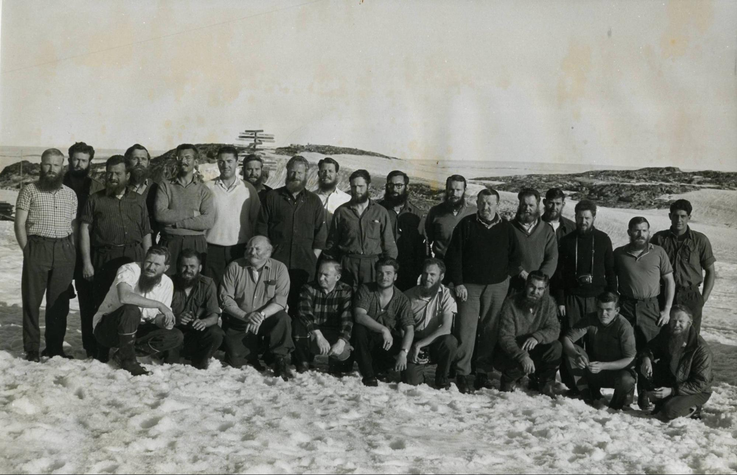

The 1966 Wilkes expeditioners in the group photo above

Back row standing Left to Right: Alan Humphreys (Cosray Eng.), Kevin White (Cosray Physicist), Jack Sillick (Plumber), Tony Blundell (Radio Op), Ted Elkington (Doctor), Dennis Willmett (Radio Op), Andrew Sparks (Cosray Tech), John Beck (Quartermaster) Dick Monks (IPSO), Leigh Pfitzner (Glaciologist), Noel Barrett (Met Tech.), Alan Sawert (Radio Op), Alan Blyth (OIC), Joe Bray (Mech.& Dogs.), Bruce Neilson (Radio Op), Bob Roff (Mech.), Rodger Williams (Radio Sup.Tech.), Bob Nicholson (Carpenter).

Front row squatting Left to Right: Jock Taylor (Seismologist), John Elliott (OIC Mech.), Steve Kaloczy (Cook), Stan Taylor (Electrician), Roger Peterson (Met OIC), Tony Groom (Met Obs.), Ted Giddings (Ass Cook/Dogs), Colin Huddy (Radio Tech.), Hans Brinkies (Met Obs.).

1966 - A year at Wilkes.

We sailed on the Thala Dan from No.6 North wharf, Melbourne, on January 10 1966. On board we had 27 expeditioners to winter over at Wilkes, and a number for Dumont d’Urville. We reached Dumont d’Urville on January 18 where we enjoyed the wonderful hospitality of the French, mostly with Australian wine and lots of Pernod. After being beset in the ice for a day or so, Thala reached Wilkes/Newcomb Bay on January 25. On the way in we had a helicopter visit from Phil Law. Phil had arrived earlier on the Nella Dan with building material for Repstat (Casey). Phil informed us of his decision to resign as Director from AAD.

After the fire works and explosive welcome, we started unloading the ship. During this period the outgoing party found time to show us the US equipment we were to operate and maintain. Ted Simmons showed me the ins and outs of the Ground Meteorological Detector (GMD), a 1680 MHz auto tracking Radio Theodolite used to follow balloon borne radiosondes. Ted also introduced me to the cantankerous Baker Hydroneal generator. This unit produced nitrogen and hydrogen by passing ammonia over a platinum catalyst in a retort at high temperature. The nitrogen and hydrogen mix was used to fill our balloons. By the end of the year I thought we had found a way to prevent retorts from cracking. When the Baker failed, bottled hydrogen was used. Releasing balloons in the high winds without damaging the radiosonde was a trick. Sometimes in blizzards, 3 or 4 attempts were needed to get one airborne. The balloon shed was moved to Casey after Wilkes was closed. As well as the normal met equipment, we also had Sferics direction finding equipment to locate the position of thunderstorms and fronts. This was carried out simultaneously with met stations at Guilford WA and Laverton, Victoria. As this was done by radio telephone to OTC in Sydney, we were able to make short calls to home after the Sferics skeds. No other Australian bases could do this.

By the time the last ship had sailed on February 9 we had unloaded all the material for Repstat and completed two more buildings. Rosters were then drawn up for slushy duties and night watch and we settled down to life in comfortable Wilkes with its interconnecting corridors (even though some filled with drift during a good bliz).

Slushy (kitchen hand) duty at Wilkes followed a routine common to all Australian bases. On Sunday the incoming slushy was shown the ropes by the previous weeks slushy who was now that Sunday’s cook. This provided Steve Kaloszy with a day off. Steve produced fantastic meals all year. There was always fresh bread and his beef wellington was to die for, there was always some left over in the cold safe just outside the kitchen for that extra slice. Ted Giddings produced P&O (shipping line) quality deserts and other treats when given the chance and particularly when he was on Sunday duty. As many of us were 2nd timers we knew the ropes and how to get additional spirits ashore in our kit bags. The contraband spirits were used in making cocktails for the Sunday morning “elevenses”. This was a gathering in Stan Taylor’s donga at 1100 hrs to prepare us for lunch. As Sunday’s lunch was being prepared by the outgoing slushy it could be anything. I can only remember one disaster the rest were creative successes. Rodger Williams though, is to be remembered by not ever providing a Sundays lunch!

My first night watch was on February 19 with music by Sibelius helping to keep me awake. On my next night watch, 3UZ, a Melbourne broadcast station, helped me to stay awake. The routine for night watch was much the same for all of us. Duties commenced at 2200hrs with the inspection of the Cat diesel generators and all the heaters. (Wilkes power was 115v ac at 60 Hz). Key heaters in the food stores and the Jamesway with our 4 fresh water tanks were checked along with all the others. Fresh water at Wilkes was obtained from a melt lake some 900 yards east of the main camp. Getting the water involved drilling through the surface ice into the lake and then pumping the water into an insulated tank heated by a Herman Nelson on a sledge. This was then towed back to base by Weasel or Bombardier and the water pumped into the above mentioned tanks. (It was never as easy as this. Motors on the pump and the drill did not always start or they would stop with the water freezing in the pump or the hose to the tank or the drill would jamb in the ice. On occasions, a blizzard would arrive just as you started!) Other duties on night watch included cleaning out the mess and washing the floor particularly after “Bourners” (A light snack between dinner and a midnight chompers – usually a cup of Bournevita plus toast, sardines, smoked oysters, tinned ham (Trim a bit like Spam) and left over puddings etc). I used to look forward to Trim sizzled on the AGA with hot mustard and toast ie bread sizzled on the AGA hot plate for half a minute per side. I had the company of the last radio operator on duty until early in the morning. I was then the only person on duty until 0630 when the first met man was woken. When I was not on night watch, this was usually me for the first balloon sonde flight. Others spent their night watch doing other things. Stan Taylor used to de-stain all the cups, Ted Giddings cleaned the rec-room, while Ted Elkington concentrated on scrubbing the duck boards and rubber matting in the showers.

Bob (Kiwi) Nicholson, Jack Sillick and Stan Taylor moved semi- permanently to working at Repstat. They were assisted at times by a volunteer from Wilkes. In April I spent a week there working on the tunnel with Bob and Jack. During this period Ted Elkington took Rodger Williams appendix out back at Wilkes. We finished the tunnel on the April 13 and I cooked cottage pie using tinned potatoes, tinned braised steak and onions and peas with blanc mange for pudding. Next day we celebrated on Jack’s BSA motor bike which had straw filled tyres. The back wheel had football boot studs on it for traction. The record time on the sea ice around the nearest island was 63 seconds. I returned to Wilkes by Polaris on April 15.

Stan was chief cook and bottle washer at Repstat most of the year, as well as being the electrician. The main meal on his menu was “Bear Stoo”. During one particular blizzard when the wind reached 114mph, Stan had his bags packed ready to leave for Wilkes at one o’clock in the morning. He thought the buildings were going to collapse. Jack was mainly concerned with building the tunnel and hoped never to see another curved sheet of galvanised iron. Bob did the carpentering and other work and instead of toys, started playing with Traxcavators among other things.

Early in the year, Hans Brinkies moved Radio KOLD (1572 kHz) from its sacrilegious position in the chapel and set up a new ‘studio’ in the Met section. It was now easily accessible to both Met and Radio men to operate in their spare time. (The Ham radio gear stayed in the chapel until the quad blew down later in the year.) Hans and Tony Blundell provided a nightly news service – mainly for the men at Repstat. As there were technical problems with the transmitter because of its proximity to Dick Monks’ Ionosonde, I decided to design and build a new transmitter that could be installed in the main transmitter building (now Wilkes Hilton) and operated over spare cable pairs from the ‘studio’ in the Met Office. The new transmitter was built from surplus bits with an 807 in the final. It was powerful enough to be heard by the field parties at the furthest point on the ice dome. This resulted in a series of DJ programmes from John Beck, Tony Groom and Bob Nicholson. Features for the spring traverse party included news, local weather, ship’s position, jazz, and classical music. Much of this had been recorded on tapes in the US. When the ships were due, we played requests for the crews. Being a fan of Sibelius I was surprised to find Danes who enjoyed his music too. I only ever played Sibelius when on night-watch!

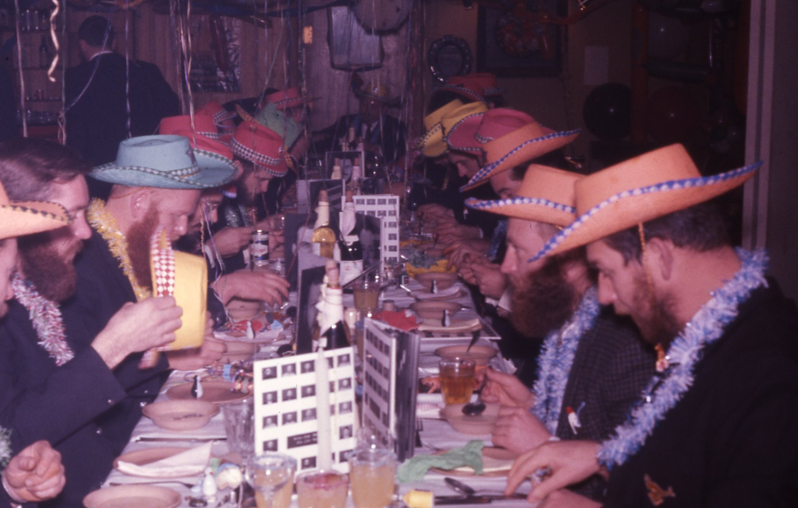Mid winter was celebrated on the June 22. As the play Cinderella was not yet entrenched in Antarctic folk law, Roger Peterson, Hans and I put on a new play based very broadly on Shakespeare’s Romeo and “Yooliet”. Most of the “broads” were not in the play but in the Miss Wilkes contest. The contest was between the “heavies” – John Beck, Steve, Bruce (Gangles) Neilson and Jack Sillick, all dressed in home-made fur bikinis and rope hair. Gangles, who had always been known as Miss Wilkes (because you couldn’t imagine anything less like a Miss Wilkes) won the coveted sash for “Miss Antarctica” and threatened to kiss the judges. Steve, assisted by Ted Giddings and John Beck, produced a magnificent feast of prawn cocktails, roast duck and bombe alaska. Steve also made a huge cake showing all the buildings of the station including the met building with a tiny hydrogen filled balloon (condom) flying over it. Interestingly, we all dressed for lunch in our sharp ANARE jackets and ties in those days!

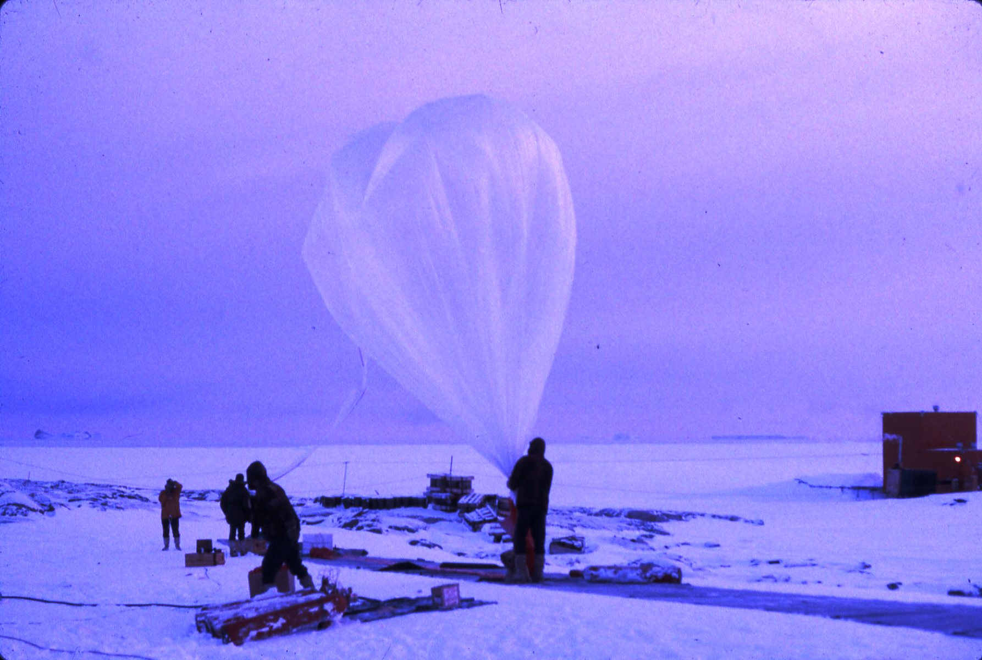A fortnight after the second successful Cosray balloon launch (the first was in May) by Kevin White, Andrew Sparks and Alan Humphries in September, it was decided it was time to stir up the Repstat party. On September 14, Kevin, Alan, Colin Huddy, Tony Groom and I walked over pack and sea ice during the night to relocate the Repstat toilet. The pan toilet was in a small hut sitting on sea ice just off shore from the station. We had a lot of trouble moving the hut as the wooden sleepers it was sitting on had frozen into the ice. After some effort, we managed to lift the hut up and move it to behind one of the small islands, leaving the pan and seat naked on the sea ice. While we were doing this, one of the Repstat party shutdown their power generator for the night. We then returned to Wilkes to await a reaction from Repstat. The whole operation took 2 hours. Next day there was no response from Repstat - all very quiet about last night. It turned out that it was Stan, who shut down the generator and he was first to go down to use the toilet in the morning. Instead of Stan blaming Bob and Jack for moving the hut, they blamed him. No one suspected anyone from Wilkes. (Stan was ex British submariner whose sub was ‘soonk’ by the Italians. He spent the rest of the war as a prisoner enjoying the company of Italian women. He wintered with me at Macquarie Is in 1964.)

In October, Kevin White, Joe Bray and I set out with 11 dogs for Haupt Nunatak. We made good time across the sea ice in fine calm weather and decided to camp for the night on Browning Peninsular. We pitched our polar pyramid tent straddling the Antarctic Circle or so we thought. The next two days were spent huddled in the tent with the occasional sortie outside as it blew and blew with gusts to at least 85 knots. The third day was calm and overcast so we made a dash for Haupt. We then intended to follow our outgoing route over the sea ice, however we found the blizzards of the previous days had broken the ice up some what. Never the less, we chose the sea ice route we thought we knew instead of the crevassed hinterland. When we looked back from the top of Robinson Ridge, nearly all the sea ice we had travelled over was gone. We then made a dash across the remaining sea ice in Sparkes Bay up on to the Michell peninsula where we camped for the night on blue ice in another blizzard. On the next day we made a dash for Wilkes, arriving in time for morning tea. We had covered about 54 miles.

Dogs were used on a 3 day official trip to Strain Grid ‘A’. On this trip Doctor Ted and Tony Blundell, Leigh Pfitzner and Joe Bray, each with a 7 dog team, had a pretty exciting time with sledges overturning many times while crossing a blue ice slope, narrow crevasses and travelling by night to reach camp before a blizzard. They beat the blizzard which lasted for 5 days by an hour. Other trips were also made. Dick Monks, Alan Humphreys and Tony Groom visited Jack’s Donga and the plane wreck. Tony, Jack and ‘Humph’ also made a trip to Haupt Nunatak by the inland route. They covered 87 miles in 6 days including 2 days blizzed-in. The dogs, as well as keeping us sane, did other trips during the year totalling about 400miles. They were reliable, never ran out of fuel, or dropped a track and above all were easy to start.

Several Strain grids were set up as part of the glaciological activities at Wilkes measuring the out flow from the Wilkes Ice Dome (now known as Law Dome). Two major traverses were undertaken. The first in Autumn, 2nd March – 13th May and the Spring 7th October to 12th December all were led by Leigh Pfitzner.

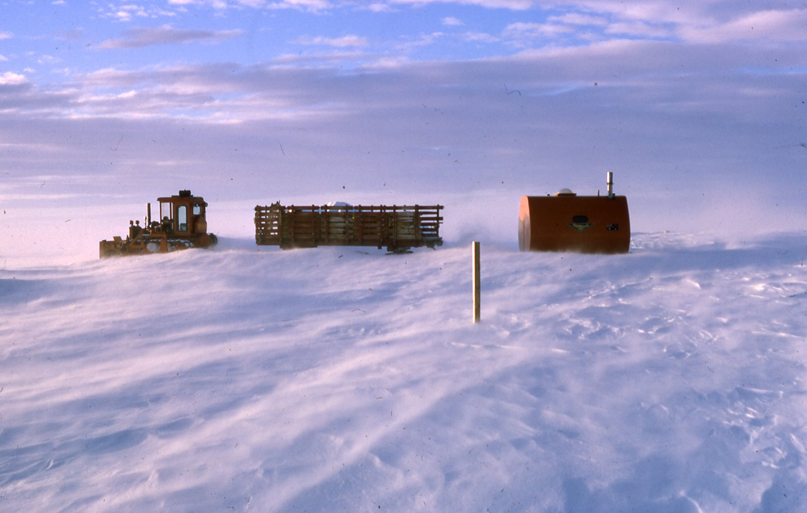In December, four of us set out to remark the route to S2 with 44 gallon drums. This was to help helicopters find S2 during the change over. With perfect weather, Ted Elkington, John Elliot, Alan Humphries and I left at 0430hrs with a D4 towing an articulated sledge full of drums and an RMIT caravan. We made good time and arrived at S2 at about 2100hrs. We had followed the existing route wiring new drums to the old as they were disappearing into the ice. We found the hatch to S2 and climbed down into the submerged kitchen and made our way down the120ft shaft to the bottom. At midnight in daylight with 20 knots of wind and a light surface drift we saw a massive iceberg break off the Vanderford Glacier which we estimated was 10 miles long. Next morning it was blizzing at 60 knots with gusts to 80. This went on for three days. On the fourth day it eased a bit but with drift reducing visibility we had to wait until 1700hrs before leaving S2. We had whiteout from Blyth junction and arrived back at Wilkes at 0605hrs – average speed 4.5 mph all the way. I rode the trip down braced in the RMIT caravan reading Lansing’s “Endurance” cover to cover.

According to my diary, we ran out of beer on January 1. Grown men were then seen to be drinking from cocktail glasses filled with Vino flor sherry and an olive. The Nella Dan was due on January 9 and the Thala Dan on January 20 but both were stuck in the pack ice. The USCG cutter Eastwind tried to assist but was also beset for a short period. On February 2 Nella broke free of the pack ice. Thala arrived 4 days later on February 6 1967. We left Wilkes on the day I was to be married – we postponed it until February 28.

I haven’t covered the movie nights and how our projectionist Bob Rolf, tried in vain to control his patrons, or the Disco with its specially brewed stout, or the IBMs (instant board meetings) by the beer brewing board to put another dozen bottles of home brew on the bar if the night was kicking on, or the discussions, intellectual, or other wise and the rule that information gleaned from magazines in the heads (toilet) could not be used to support any argument, or how we validated OIC Alan’s official notices by checking his signature was exactly at 45 degrees.

We had a good year with lots of fun as well as completing our works programme. I have relied on three sources for the above; the station year book, my personal diary and my memory. The latter still recalls much of the year and those I shared it with. Pity I can’t say same about yesterday.

Noel Barrett

